APPENDIX – A

**SCOPE OF WORK**

**For**

Repair Communications Towers 9352

**FOR PROJECT XLWU 21-8112**

**TYNDALL AFB FLORIDA**

**Tyndall AFB, FL**

**Site Runway South (RWS) Tower Building Number 9352**

**Tower Replacement Project**

**Technical Requirements Document (TRD)**

**Table of Contents**

1. Introduction 4

1.1. Purpose of TRD 4

1.2. Scope of TRD 5

1.3. Tower Procurement Components 5

1.4. Equipment Shelter Components 6

1.5. Site Enclosure 6

1.6 References……………………………………………………………………………..5

2. Definitions 7

2.1. Tyndall Site RWS Replacement Tower 7

2.2. Tyndall Equipment Shelter 7

3. Requirements 7

3.1. RWS Replacement Tower Project General Description 7

4. Quality Assurance Provisions 17

4.1. General 17

4.2. Responsibility for Verification 17

4.3. Responsibility for Compliance 18

4.4. Test Equipment and Facilities 18

4.5. Methods of Verification 18

5. Tower Specifications 19

5.1. General 19

5.2. Detailed Specifications 20

6. Subcomponent Specifications 21

7. Demolition 22

8. Site Security 23

APPENDIX A 21

APPENDIX B 22

APPENDIX C 23

APPENDIX D……………………………………………..…………………………………24

## **Introduction**

## Purpose of TRD

## The purpose of this Technical Requirements Document (TRD) is to define and establish the performance, design, development, and functional test requirements for the RWS Tower Replacement Project. The Project will include the demolition and replacement of the Runway South (RWS) tower, Tyndall Real Property Building Number 9352. As well as, replacement of the facility equipment enclosures.

## The project’s systems will:

## Be installed on Tyndall Air Force Base (AFB), FL (see Figure 1).



**Tyndall AFB, FL**

*MC900349993[1]*

**Bldg 9352**

**Figure 1 - Tyndall - Relative Building Location**

## Be integrated into existing utility and infrastructure assets.

## Include infrastructure modifications as necessary.

## Work to be completed without interruption of existing portable tower service.

## Be a Turn Key Project

## Meet all current wind load requirements for the location. Current Tyndall AFB requirements specify 170 mph design wind speed.

## Meet all current FAA tower lighting and marking requirements.

## Tower shall be ~~four~~ three (3) legged, self-supported with no guy anchors.

## Foundation Design: Tower shall be constructed using deep foundations, no shallow footings or guy anchors will be allowed for this project with the exception of new equipment shelter that requires a shallow pad/footing.

## Meet all current FAA tower lighting and marking requirements.

## The Equipment Shelter will:

## Be a complete power ready system.

## Phasing of tower 9352 65%/95%/100% design submittals and construction activities within the overall task order shall be submitted to the government for review and approval.

1.1.1.2.3 New tower shall be located as close as possible to existing tower in order to maintain FAA certification by end user after project completion.

1.1.2.4 Existing security perimeter fence around existing guyed tower can be removed to allow for construction of the new self-supported tower structure.

## **Scope of TRD**

## The requirements described herein are provided to encourage maintainable and sustainable architectural approaches while still meeting by part number requirements where applicable. Maximum use of standard Commercial-off-the-shelf (COTS) items will be considered.

## A brief summary of the subject TRD sections is provided below:

## Section 1: Introduction

## Section 2: Definitions

## Section 3: Requirements

## Section 4: Quality Assurance Provisions

## Section 5: Tower Specifications

## Section 6: Subcomponent Specifications

## **Tower Procurement Components**

## The replacement tower and Antenna Systems shall be a turnkey project that will include:

## Tower Top Plate Height of 148 feet Above Ground Level (AGL)

## Two Antenna Systems.

## Supports and brackets for two Antenna Systems

## A Dissipative Grounding System for the Structure (Tower and Equipment Shelter)

## Grounding Systems for two Antenna Systems

## Vertical Waveguide Management System

## Safety Climb Cable System

## Aviation Obstruction lighting and markings.

## **Equipment Shelter Components**

## The Equipment Shelter shall be a turnkey project that will include:

## A 2-phase 60Amp, Ten (10) circuit breaker panel

## Two (2) 37U (minimum) 4-post Open Frame Equipment Racks

## Rack vertical power strips from separate circuits.

## Shelter Cable Management System

## Climate Control System.

## Site Enclosure

## 8ft chain link galvanized fence, 7ft fabric with 1ft Barbed wire cap

## 16ft Entry Gate Opening, Two 8’ Swing type gates with barbed wire cap. New entry gate opening shall face existing access road.

## Fence and Gates shall be grounded and connected to the Dissipative Grounding System

## Gates shall have lockable security latches

## References

The documents listed in this section form a part of this TRD to the extent invoked by specific reference in other paragraphs of this TRD. In the event of conflict between the documents referenced below and the contents of this TRD, the contents of this TRD will supersede.

| Classification | Standard | Title | Date/Rev | Controlling Organization |
| --- | --- | --- | --- | --- |
| Government | Occupational Safety and Health (OSH) Standard 1910.97 | Non-ionizing Radiation | 7 Mar 1996  Rev: N/A | U.S. Department of Labor,  Occupational Safety and Health Administration (OSHA) |
| Military | AFI 32-1065 | Air Force Instruction – Grounding Systems | 1 Oct 1998  Rev: N/A | Secretary of the Air Force,  HQ AFCESA/CESE |
| Industry | TIA-222-H Standard | Antenna System Grounding | 2017/H | Telecommunications Industry Association (TIA) |
| Industry | ACI 315 | Details and Detailing of Concrete Reinforcement | Latest Edition | American Concrete Institute |
| Industry | ACI 318 | Building Code For Structural Concrete | Latest Edition | American Concrete Institute |
| Military | MIL-HDBK-419A | Grounding Bonding, and Shielding for Electronic Equipment and Facilities | Latest Edition | DOD |
| Military | Tyndall AFI 31-101 | Air Force Installation Security | Latest Edition | 325th Security Forces |

## **Definitions**

## **Tyndall Site RWS Replacement Tower**

The RWS Replacement Tower and Antenna Systems consists of a steel tower and antenna systems which will replace current RWS tower, antenna systems (building number 9352) located on Tyndall AFB, FL.

## **Tyndall** Equipment Shelter

The RWS Equipment Shelter will replace existing fiberglass equipment enclosures, outdoor service disconnect switch and outdoor circuit breaker panel located on Tyndall AFB, FL.

## **Requirements**

## **RWS Replacement Tower Project General Description**

## **Operational/Organizational Concepts**

## The Government provides air-to-air weapon test support to multi-service programs, Developmental Test and Evaluation (DT&E) efforts, Operational Test and Evaluation (OT&E) missions, and the Weapon System Evaluation Program (WSEP).

## The GRDCS antenna (2) provides the primary link between the GRDCS control facility at Tyndall AFB and drones operating over the Eglin Test and Training Range (ETTR). The GRDCS antenna is used during 100% of the drone control activities performed by the 53 WEG. The RWS GRDCS antenna is the central node for GRDCS triangulation-based operation of all drone launches, and missions in the Western section of the ETTR.

## Procurement Description

## The RWS replacement tower project will result in a 148-foot tower which supports two independent antenna systems: two Gulf Range Drone Control System (GRDCS) (DLS and DLSR). It will also include an Equipment Shelter to provide uninterrupted power and climate controlled environment for the GRDCS transmitter receivers.

## In addition, the procurement will include applicable:

## Technical, safety, and as built documents and drawings.

## Maintenance instructions as applicable.

## **General System Description**

## The RWS replacement tower is comprised of the system components listed below:

## RWS Tower *– See Section 3.1.4*

## Equipment Shelter – See Section 3.1.5

## **RWS Tower General Description**

## The RWS replacement tower is comprised of the system components listed below. The Transmitter systems are shown for illustration of functionality, the contractor will not be required to provide the transmitter-receivers as they will be existing government owned and operated items. Whereas, the complete antenna system will be provided and installed by the contractor.

## Transmitter Systems *– See Section 3.1.4.2*

## Antenna Systems – See Section 3.1.4.3

## **Transmitter Systems**

## **Transmitter Systems Definition**

## The Transmitter System (see Figure 2) is comprised of:

## Two (2) GRDCS Data Link Systems (DLS)

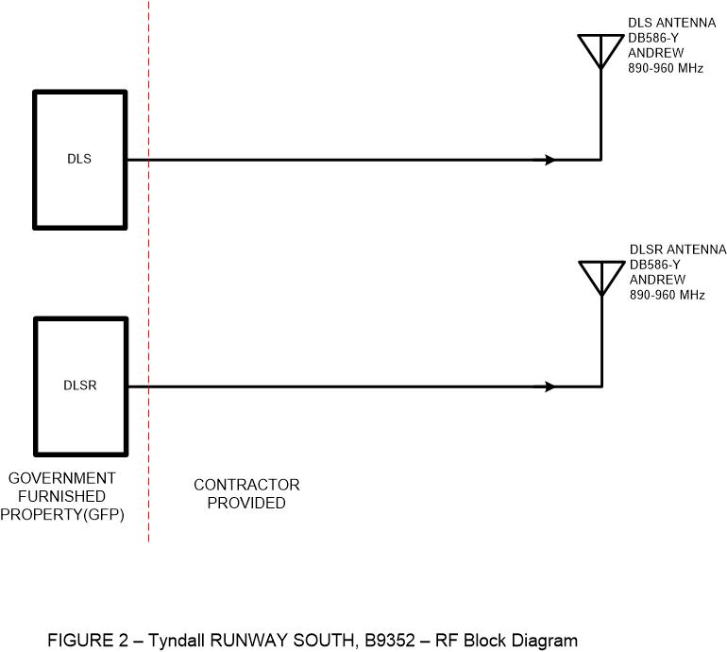

## **Transmitter Operating Frequency**

The DLS/DLSr transmitter operates at 905-925 Megahertz (MHz). The government test plan will specify specific frequencies for the live antenna system tests.

## **Transmitter Output Power**

## The GRDCS transmitter, Data Link System (DLS/DLSr) transmitter output power is 48 EIRP (Watts).

## The test plan will define a stepped approach to reach maximum power for live antenna system tests.

## **Antenna Systems**

## **Antenna System Definition**

## The GRDCS Antenna System (see Figure 2) shall be comprised of:

## Two (2) UHF transmit/receive antennas.

## Two (2) High Power, Low Loss Transmission Line, associated Connectors and Grounding.

## The contractor shall consider maximum use of standard COTS items in their design and implementation of the RWS replacement tower Antenna Systems.

## **Antenna Type**

## The DLS/DLSr antennas shall be omni-directional, Model DB586-Y manufactured by Andrew Inc (CommScope) (see Appendix B).

## For each complete Antenna System, the contractor shall ensure and document a Voltage Standing Wave Ratio (VSWR) test across the transmitter operating frequency bands specified in Para 3.1.4.2 . The VSWR shall not exceed 1.5:1.

## **Antenna System Locations and Quantities**

## The RWS Tower Replacement Project will include installation of two (2) Antenna Systems at Building 9352 as specified in Para 3.1.4.3. Antenna locations are specified in Appendix C.

## Each antenna will interface to one UHF Transmitter/Receiver.

## The procurement will include two (2) Transmitter Antenna Systems. These Antenna Systems shall be comprised of:

## Two (2) each “transmit/receive” antennas.

## Two (2) each Transmission Lines.

## **Power Transmission Lines**

## The contractor shall provide and install two high power transmission lines between the Equipment Shelter Port Panel and the GRDCS omni-directional antennas. The transmission lines shall be terminated with N-type RF connectors compatible to the transmission line. The lower connector shall be mounted to the RF Surge Protector. The total insertion loss for this high power transmission line shall not exceed 0.7 dB per 100 ft.

## **RWS Equipment Shelter General Description**

## The shelter shall be a complete power ready system.

## The RWS Equipment Shelter is comprised of the system components listed below.

## RF Entry Panel *– See Section 3.1.5.3.*

## Equipment Racks – See Section 3.1.5.4.

## Breaker Panel – See Section 3.1.5.5

## **RF Entry Panel**

The RF Entry Panel will consist of: Entry Panel with minimum four (4) each 4” ports, such as SitePro1 p/n E1199. Two (2) each 4” Boot Kits, such as SitePro1 p/n BA158. Arrestor Trapeze, such as SitePro1 p/n ATK306U. Two (2) Surge Arrestors, such as PolyPhaser p/n TSX-NFF. Equivalent parts may be utilized.

## **Equipment Racks**

Two (2) 37U(minimum) 4-post Open Frame Equipment Racks, such as StarTech p/n 4POSTRACK36, or equivalent with a vertical power strip capable of mounting standard 19” equipment 24” deep. Racks shall be floor mounted and grounded. The racks shall have three (3) feet clearance on the front and rear to support maintenance.

The racks shall include a cable management system to support cabling from the RF Entry Panel, and VAC entry port.

## **Circuit Breaker Panel**

The VAC panel shall be 2-phase, 10 circuit minimum, with Main Breaker and Surge Suppressor.

## **Ice Bridge**

The Ice Bridge will be installed from the tower vertical waveguide management system to the Equipment Shelter Port Panel. The ice bridge shall be constructed of 3.5” OD SCH40 galvanized pipe, galvanized bridge channel, galvanized U-bolts, and galvanized retaining hardware, such as SitePro1 part# IB12D-Z or equivalent. Ice Bridge shall be grounded and posts shall be secured with concrete as indicated in Figure 4.

## **Site Enclosure**

The Site shall be encompassed in an eight (8) foot barb wire capped chain link fence, matching existing enclosure. The fence shall have a double swing type six (6) foot gate, creating a twelve (12) foot opening. All enclosure posts shall be installed in concrete. The fence and gates shall be grounded and connected to the dissipative grounding system.

## **RF Authorization**

The UHF emitters at RWS Site are covered by the current Tyndall AFB WEG RFA.

## **Personnel Safety**

## The contractor shall comply with U.S. Department of Labor standard OSHA 1910.97 (Non-ionizing Radiation), for personnel during the live high power system tests by ensuring personnel are not on the tower.

## In addition, the contractor shall comply with AFI 32-1065 (AFI - Grounding Systems) for communications facilities.

## **Government-Furnished Property (GFP)**

As specified throughout the TRD, the Government will provide to the contractor certain GFP items (as listed below) that require integration into the RWS Tower Replacement project.

* DLSR transmitter-receiver
* DLS transmitter-receiver
* RF jumper cables from Equipment Shelter RF Surge Suppressor to Tx/Rx (DLS/DLSr)

## **Installation**

## Proposed tower and equipment shelter shall be located near existing tower at 30°00’47.20” 85°31’19.04”. The contractor shall install all RWS Tower Replacement components at the locations specified within Section 3.1 "RWS Replacement Tower General Description" and Figure 3.

## The Tower, Antenna Systems, and Equipment Shelter will be installed outdoors on designated Government property, in a moderate salt spray environment that (tower, each antenna, power transmission line, associated mounting hardware, and equipment shelter) shall require where applicable the use of non-corrosive materials and the application of appropriate corrosion prevention. The antennas shall be mounted as high as is feasible on the tower (antenna bases no lower than 147’) and in the configuration as indicated in Appendix C. The UHF antennas shall have a minimum separation of 6 feet, horizontally. The tower shall be loaded to no greater than 50% wind load capacity after the installation of all herein specified hardware, to include antenna systems, grounding, lighting, safety cable, ladder, etc. Therefore, the end user shall be able to double the as-built tower wind load without exceeding the wind load limit of the tower. At the program PDR, the contractor shall propose (and the Government will establish) the environmental thresholds for operating, non-operating, and survivability conditions with respect to the Antenna System installations. These thresholds shall include, at a minimum, temperature and wind speed.

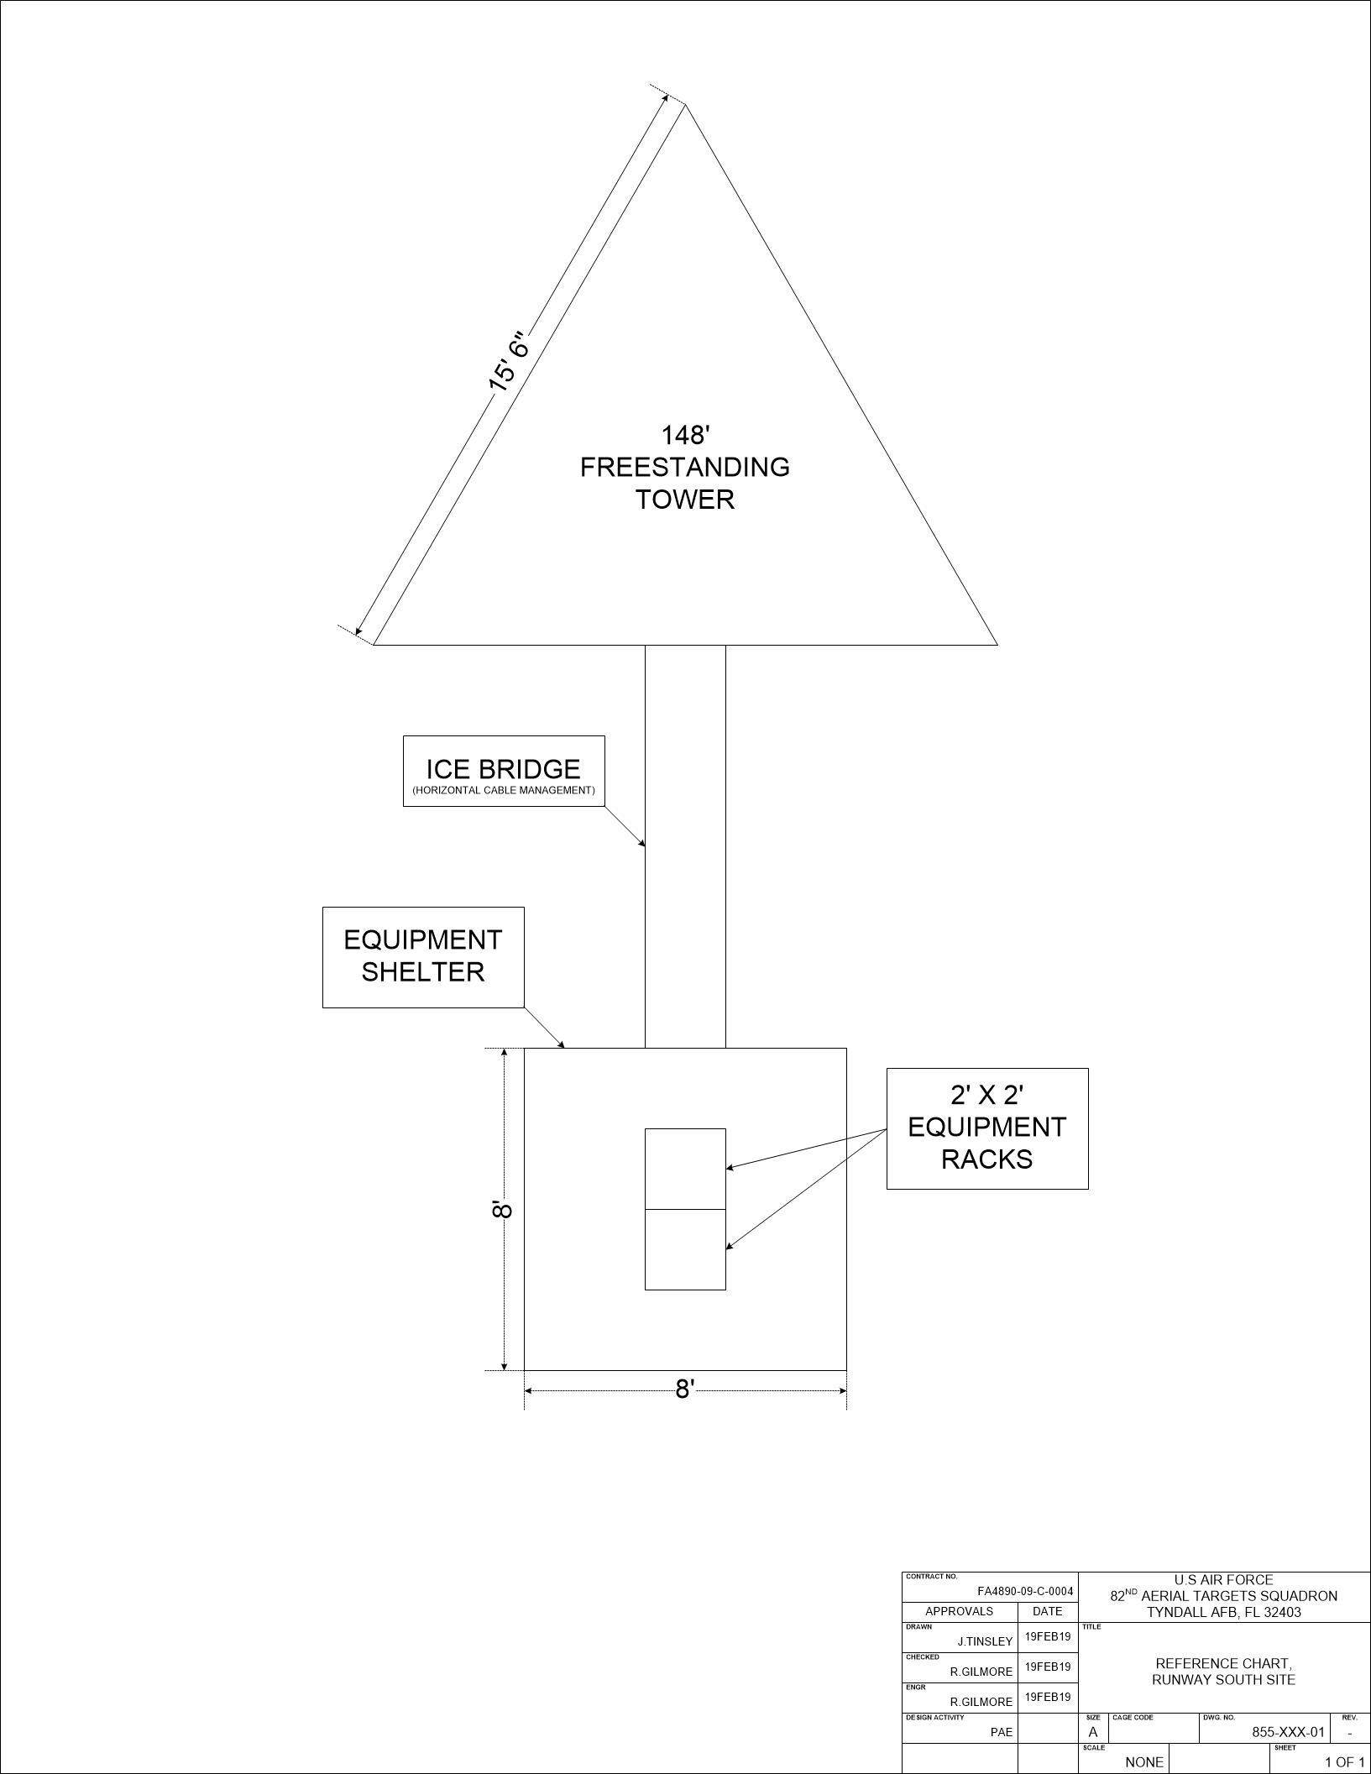

**Figure 3 – Tower and Equipment Placement (Notional)**

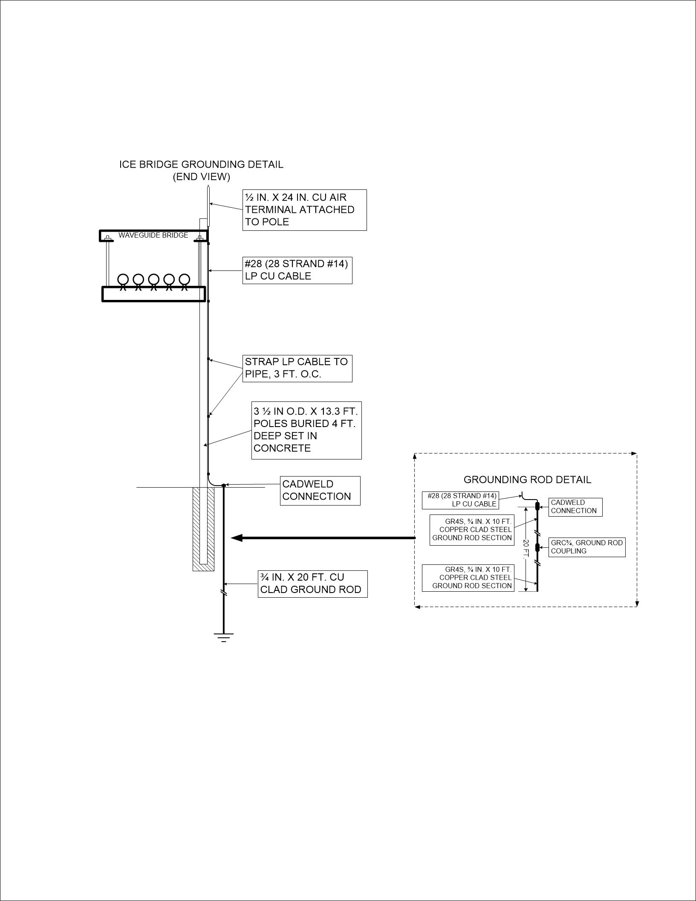

**Figure 4 – Ice Bridge and Grounding (Notional)**

## **Tools**

## The contractor shall provide a list of all specialty tools required to maintain the Antenna Systems

## **Documentation**

## For the RWS Replacement Tower and Antenna Systems procurement, the project TRD will address the system documentation requirements, while the program Contract Data Requirements List (CDRL) Package will designate the documentation delivery requirements.

## Drawings and schematics shall be provided in paper and electronic format. Two full size paper copies shall be provided plus one engineer’s copy. Paper copies will be no smaller than ANSI/ASME Y14.1 standard B or ISO standard A3 size. Two electronic copies shall be provided in PDF format and the native format on CD or DVD. An example of native format would be a “dwg” if AutoCAD was used to generate the drawing.

## A list of all software titles (and revision) that were used to generate the drawings shall be provided.

## The program documentation will include at a minimum:

## Design review agendas, briefing charts, and related meeting minutes.

## Design documents:

## Hardware: Tower and Subcomponent Design Specifications

## Construction Documents

## Prior to the preparation of the new tower Erection Documents, the Contractor shall prepare Construction Documents for Government approval. Construction documents shall include drawings and specifications as necessary to illustrate the complete tower design, including all structural components (super structure and substructure), utilities, equipment, hardware, devices and finishes. Control dimensions, member sizes and other details shall be included as necessary for the development of Erection Documents.

## Erection Documents

## Upon approval of the Construction Documents by the Contracting Officer's Representative (COR), the Contractor shall generate Tower Erection Drawings. Tower Erection Drawings shall indicate anchor bolts, member locations, bolt sizes and numbers, and all other information to clearly depict requirements for erection of the tower. A parts list showing the member number, size and length shall be provided with the Erection Drawings.

## Design Data

## All construction and erection drawings and specifications shall be prepared to comply with this specification. This specification describes the design work that shall not be changed, without prior approval of the Government, and shall be included in the construction documents. All remaining design work shall be performed by the Contractor based on the design criteria as required herein. No deviations from the criteria will be allowed unless prior approval is obtained from the Contracting Officer's Representative. All questions or problems encountered by the Contractor shall be promptly submitted with recommendations for resolution to the Contracting Officer's Representative for approval. Contents of this specification shall not be construed as limiting in any way the responsibilities of the DOR to comply with all code requirements.

## Certificates, Engineer and Manufacturer Qualifications

## Identify the Designer of Record (DOR) and submit written qualifications of the DOR providing evidence that he/she is a Professional Engineer registered in the state of Florida and has a minimum of 5 years’ experience in the design of steel tower structures of similar height and performance.

## Identify the tower manufacturer and submit written qualifications providing evidence that the manufacturer has a minimum of 10 years’ experience fabricating steel tower structures of similar height and performance. The manufacturer shall have completed a minimum of 3 similar projects within the past 5 years.

## Provide Certificate of Completion.

## Test procedures/reports:

## For the subcomponents:

## Subsystem ATP and Subsystem ATP Report

## Antenna VSWR Test Procedures and related Test Report

## Grounding:

## Measurement of tower primary ground to earth ground in ohms.

## Measurement of tower and guy point lightning ground to earth ground in ohms.

## Measurement of tower signal ground to earth ground in ohms.

## Drawings, Bill of Materials, and Component Data Sheets (to include any referenced materials)

## Schematics

## Breaker Panel Schedule. Appendix D.

## Site Grounding Plan, Enclosure Fence Grounding Detail, Shelter, Ice Bridge, and Tower Grounding Detail.

## Test procedures/reports:

## **Maintenance and Sustainment**

During installation and test, the RWS replacement tower and associated systems' maintenance and sustainment will be the contractor's responsibility until successfully completed and turned over to the Government.

## Maintenance Concept

The contractor shall provide technical documentation that enables the Government to perform organizational (field-level) preventative maintenance and repair.

## **Maintainability/Sustainment Design**

The contractor shall design the RWS replacement tower for ease of maintenance and to sustain a projected minimum 15-year life span.

## **Quality Assurance Provisions**

## **General**

## The Quality Assurance (QA) verification provisions described herein include the verification methods necessary to verify the ability of the tower and antenna systems (and/or components) to meet the performance, design, development, and functional test requirements specified herein.

## To verify conformance to the system requirements, QA verifications shall be (as approved by the Government) accomplished via:

## Analysis (Reference 4.5.1

## Inspection (Reference 4.5.2

## Functional Test (Reference Para 4.5.3

## Systems under Functional Test shall not be adjusted, repaired or maintained unless specifically permitted by the Government. When authorized by the Government to make corrections and after corrections are made, all tests deemed necessary by the Government shall be performed to verify that the system meets the specification requirements.

## At the program PDR, the contractor shall present/document (and the Government will approve) the proposed verification method (IAW the QA verifications defined within Section 4.2) for each of the subject TRD requirements.

## **Responsibility for Verification**

## Unless specified otherwise, the contractor:

## Shall be responsible for performance of all verification requirements proposed.

## May use their own or any other facilities suitable for the performance of the inspection or test requirements specified herein, unless disapproved by the Government.

## The Government reserves the right to perform any of the inspections or tests proposed by the contractor where such inspections or tests are deemed necessary to ensure that supplies and services conform to prescribed requirements.

## **Responsibility for Compliance**

## The system design shall meet all requirements specified.

## The inspections set forth in this specification shall become a part of the contractor's overall inspection system or quality program.

## The absence of any inspection requirement in this specification shall not relieve the contractor of the responsibility of ensuring that all products or supplies submitted to the procuring activity for acceptance comply with all requirements of the contract.

## **Test Equipment and Facilities**

## Calibration of all measuring and inspection equipment, which control the accuracy of test equipment and facilities, shall be traceable to the National Institute of Standards and Technology.

## The contractor shall ensure that test facilities of sufficient quality and quantity are established and maintained to permit performance of required inspections.

## **Methods of Verification**

The requirements of Section 3.1 and 4.3 shall be verified by the method(s) summarized in the sub-paragraphs, below

## **Analysis**

## The disciplines and processes involving the evaluation, comparison, and correlation of data generated mathematically with the applicable design requirements, or the application of test and/or statistical data to mathematical analyses for comparison with the applicable design requirements.

## Requirements being verified by analysis shall, in whole or part, be verified by the results of analyses which are of sufficient scope, depth, and level of detail to assure the accuracy of the conclusions reached. This analysis is subject to approval by the Government.

## Where applicable, the results of analytical tasks performed during the engineering test and evaluation phase may be utilized. Also, data obtained from the evaluation of a similar item may be utilized, provided the work was accomplished on a configuration sufficiently representative of the final design.

## **Inspection (Examination of Product)**

## Inspection is the verification of requirements by visual examination of the physical features of a non-operating system, physical measurements and/or comparison of the system with applicable drawings and specifications.

## The inspection may be conducted with or without the aid of standard tools. The tower, grounding and each antenna system presented for acceptance will be physically examined to ensure that the meet all requirements specified herein and on the drawings for the system. Failure to pass this examination shall cause the tower and associated systems to be rejected.

## **Acceptance Tests**

## The contractor shall ensure acceptance test of the following features, parameters, or characteristics.

## Any personnel radiation hazards on expected work surfaces (i.e. ground, nearby roof tops, etc.), as determined by OSHA standard 1910.97, shall be mitigated. Posting a warning sign shall not constitute adequate mitigation

## Grounding (per AFI 32-1065)

## Primary antenna system ground documented by the contractor to demonstrate 5 Ohms or less.

## Lightning protection system ground documented by the contractor to demonstrate 5 Ohms or less.

## Antenna System VSWR.

## By the Government using GFE test equipment without GFE RF transmitters connected.

## By the Government using GFE test equipment with GFE RF transmitters connected.

## **Tower Specifications**

## **General**

## The tower furnished by the manufacturer shall be complete in accordance with all specification requirements including anchor bolts, safety climbing device and all other hardware essential for erecting the tower. The contractor shall provide all materials, supplies, equipment and services necessary to design, detail, fabricate and install the tower.

## The structural information provided herein is intended to illustrate the design intent for the tower. The structural design provided herein shall be utilized as a conceptual design. Materials provided serve to illustrate the relationships of volumes, architectural, structural, mechanical, and electrical systems. The contractor is solely responsible for the determination and complete design of the structural system. The final structural system design decisions shall not reduce the net square footage requirement as defined in this document.

## The tower designed for Exposure "C" to the TIA-222-H Standard

## Shall be designed for 170 MPH basic wind in accordance with Florida Building Code.

## Shall be designed for 30 MPH basic wind with 0.25 inches of ice.

## The tower framing shall consist of structural steel (tube or pipe) framing. Any closed members (tubes or pipes) must have appropriately detailed weep holes or other consideration for drainage. The tower shall be designed to accept minimally, two Andrew Corp Model DB586-Y. (see Appendix B).

## **Detailed Specifications**

## The following specifications address facets of the tower which will become real property and are considered part of the structure. For placement of the tower and solar powered system see Figure 3.

## Concrete

## Specified minimum compressive strength shall be 4000 psi at 28 days for all concrete.

## All detailing and materials used for concrete reinforcement shall be in accordance with ACI 315 and ACI 318, latest revisions.

## Exterior steel embedded in concrete for such purposes as base plates, anchor bolts, guy anchors, etc. shall be hot-dipped galvanized unless otherwise directed.

## Steel

## Shop connections for structural steel shall be welded, and field connections shall be made with high strength bolts in bearing type connections.

## The structural design documents and erection plan shall be reviewed and signed by a licensed structural engineer.

## Galvanizing: All ferrous structural steel shall be hot dip galvanized after fabrication in conformance with ASTM Specification A-123 and A-385. Hardware (nuts, bolts, washers and other minor items) shall be galvanized by the hot dip method. Anchor bolts shall be galvanized in the area which will extends above the concrete foundation

## Electrical

## Electrical distribution shall be installed in accordance with the National Electrical Code.

## Wiring shall be insulated copper conductors.

## All wiring shall be provided and installed in conduit.

## All conduit attached to the tower shall be galvanized rigid steel.

## Grounding

## Grounding electrode systems shall be provided for power, lightning protection and signals.

## Grounding shall meet the requirements of MIL-HDBK-419A Grounding Bonding, and Shielding for Electronic Equipment and Facilities and AFI-32-1065 Grounding Systems.

## Bonding shall be provided to tower steel, tower foundation rebar, guy wires/points, driven ground rods and the lightning protection system.

## Ground rods shall be a minimum of ¾-inch x 20 feet and be tied together with 4/0 copper cables. A grounding counterpoise consisting of 4/0 copper cable shall be provided around the tower foundation. All grounding electrode systems shall be bonded to the grounding counterpoise.

## All grounding electrode systems will have a maximum resistance to ground of 5 ohms or less and be interconnected at a single point. The grounding system will be a common grounding system and can be utilized when practical for all grounding needs.

## Lightning Protection

## A dissipative lightning protection system shall be provided, including strike termination devices, conductors, ground terminals, interconnecting conductors and other connectors and fittings required to provide a full coverage for antenna systems.

## Grounding shall meet the requirements of MIL-HDBK-419A Grounding Bonding, and Shielding for Electronic Equipment and Facilities and AFI-32-1065 Grounding Systems.

## Lighting

Two or more steady-burning red (L-810) lights should be installed in a manner to ensure an unobstructed view of one or more lights by a pilot.

## Access

## The ladder shall be mounted for the full height of the tower. The ladder design shall conform to OSHA standards including clearances. The mounting devices for the ladder to the tower shall not extend beyond the rail edges on the climbing side of the ladder. If a tower is installed with designed climbing rungs, such as Rohn 45G, then the installation of a climbing ladder is not required.

## A cable type, Safety Climbing Device (DBI/SALA, Lad safe-type or equivalent) including mounting attachments shall be installed. Contractor shall provide a safety climbing device sleeve (trolley), with self-closing/locking carabiner. Contractor shall furnish safety climbing device instruction manual and parts list.

## Security Fence

## A site perimeter chain link fence shall be installed encompassing the tower and equipment shelter. The fence shall be of adequate size to allow normal maintenance procedures on equipment as well as, tower and antenna system maintenance. Fences shall be constructed of an 8-foot galvanized chain link with barbed wire capped perimeter. The enclosure shall include a lockable chain link gate of like construction. Install a 6” layer of compacted gravel base along 10’ perimeter of fence compound for maintenance vehicle access.

## Main compound permanent fence additions or relocations to accommodate tower construction are the responsibility of the contractor.

## **Subcomponent Specifications**

## The following specifications address antenna systems which will become user owned and maintained items after installation. The user for these systems is the 53rd Weapons Evaluation Group.

## Transmission Line

## For the GRDCS antennas: Shall provide two (2) 1 5/8-inch Transmission Lines, Andrew Part # AVA7-50, between the antennas and equipment shelter entry panel. The total loss from the entry panel to the antenna input shall not exceed 0.70 dB loss per 100 feet at 900Mhz with connectors.

## The DLS and DLSR transmission lines shall be continuous with no splices or adapters. A single Andrew Part # AL7NF-PSA connector shall be used at the top of the tower connected to a 6-foot jumper Andrew part# L4A-NMNM-6P connected to the DLS antenna. A single Andrew Part # AL7NF-PSA connector shall be used at the top of the tower connected to a 6-foot jumper Andrew part# L4A-NMNM-6P connected to the DLSR antenna.

## All outdoor connections shall be sealed and weatherproofed. Andrew part # 221213 or equivalent sealing method.

## Shall be secured to the tower at least every three feet using the manufacturer's suggested mounting hardware for each mounting surface, i.e. Site Pro 1 part # 158SS-A, as required.

## Shall comply with manufacturer's installation instructions for minimum bend radius.

## Shall be grounded at the top near the antenna and on the bottom of the tower immediately above the vertical to horizontal transition point and at the RF Port Panel entry point.

## Ground kits shall be Site Pro 1 part # GK-C158, or equivalent.

## Shall be hoisted and installed using Andrew part # L7SGRIP, as applicable using the manufacturers recommended installation guidelines for support hoisting grip.

## Antenna Mounting Specifications

## Antenna mounting brackets shall be provided and installed for two (2) Andrew Corp Model DB586-Y, (see Appendix B).

## The DLS antenna mounting brackets shall be installed on the tower, with a minimum separation of six (6) feet. The two (2) DB586-Y antennas shall be mounted in horizontally as indicated in Appendix C.

## All ferrous mounting steel shall be hot dip galvanized after fabrication. Hardware (nuts, bolts, washers and other minor items) shall be galvanized by the hot dip method or may be stainless steel.

## **Demolition**

## The scope of this work includes demolition of the existing guyed tower facility number 9352. The contractor shall completely demolish and abate the entire existing tower and guy points to include foundations after all systems have been cutover and tested on the new tower. Contractor to restore existing tower site to as found condition or better after the completion of the new site development.

## Demolition Specifics

## The contractor will review all documents provided and perform a site survey to discern the full scope of work required to demolish existing facilities including requirements to maintain services currently routed through the facilities to be demolished.

## Maintain unimpeded government access to tower facility 9352. Brief periods of unavailability required to dismantle the elevated structure shall be coordinated with the government 10 business days in advance.

## Demolition efforts will not impact current utilities or operations. Although not expected to be required, any required power outages shall be detailed and coordinated by the contractor 20 business days in advance. Gov’t approved outages may require work to occur outside normal operations hours.

## Demolish structures in a systematic manner from the top of the structure to the ground while protecting adjacent facilities. Complete demolition above each tier before the supporting members on the lower level are disturbed.

## Borrow material will be obtained off site. Disposal of non-recyclable materials from clearing and grubbing, demolition and other activities will be hauled off government property and disposal in accordance with Federal, State and local regulations. All costs in connection with borrow material and disposal of materials shall be at the contractor’s expense.

## Recyclables generated from project shall become the property of Tyndall AFB Recycling Center. Metal should be cut in transportable pieces no larger than 30 ft. long and 4 ft. wide. All non-recyclable waste material generated during demolition shall be properly handled, transported and disposed of off-base by the contractor in conformance with federal, state and local regulations.

## **Site Security**

Contractor will be required to provide construction security locks in line with existing locks at the construction site as well as forest road access where applicable.

1. **Signage**

Facility # of each site shall be installed via signs. Also install any pertinent manufacturer's serial # and other pertinent information via signs on tower and/or shelters.

APPENDIX A

**Acronyms**

| **Acronym** | **Description** |
| --- | --- |
| **ACI** | American Concrete Institute |
| **AFB** | Air Force Base |
| **AGL** | Above Ground Level |
| **ANSI** | American National Standards Institute |
| **ATP** | Acceptance Test Procedure |
| **CDR** | Critical Design Review |
| **CDRL** | Contract Data Requirements List |
| **COTS** | Commercial Off The Shelf |
| **dB** | Decibel |
| **N** | Type N 50 OHM RF Connector (Connector Standard) |
| **DoD** | Department of Defense |
| **EIA** | Electronic Industries Alliance |
| **GFE** | Government-Furnished Equipment |
| **GFP** | Government-Furnished Property |
| **IAW** | In Accordance With |
| **ID** | Identification |
| **LHC** | Left Hand Circular |
| **MHz** | Megahertz |
| **OSH** | Occupational Safety and Health |
| **OSHA** | Occupational Safety and Health Administration |
| **OT** | Operational Test |
| **OT&E** | Operational Test & Evaluation |
| **PDR** | Preliminary Design Review |
| **QA** | Quality Assurance |
| **RF** | Radio Frequency |
| **SPS** | Subsystem Performance Specification |
| **SRR** | System Requirements Review |
| **TRD** | Technical Requirements Document |
| **UHF** | Ultra High Frequency |
| **VSWR** | Voltage Standing Wave Ratio |
| **WSEP** | Weapon System Evaluation Program |

## APPENDIX B

**GRDCS Omni Antenna**

**Model: DB586-Y**

Below is a photo and information on an Andrew Corp. light weight, Low profile, UHF omnidirectional antenna. This antenna provides coverage over the frequency range of 890 MHz to 960 MHz and is capable of handling a max input power of 300 watts. Input VSWR is < 1.5:1. Typical radiation pattern is available upon request.



## APPENDIX C

Tower Structure (Notional)

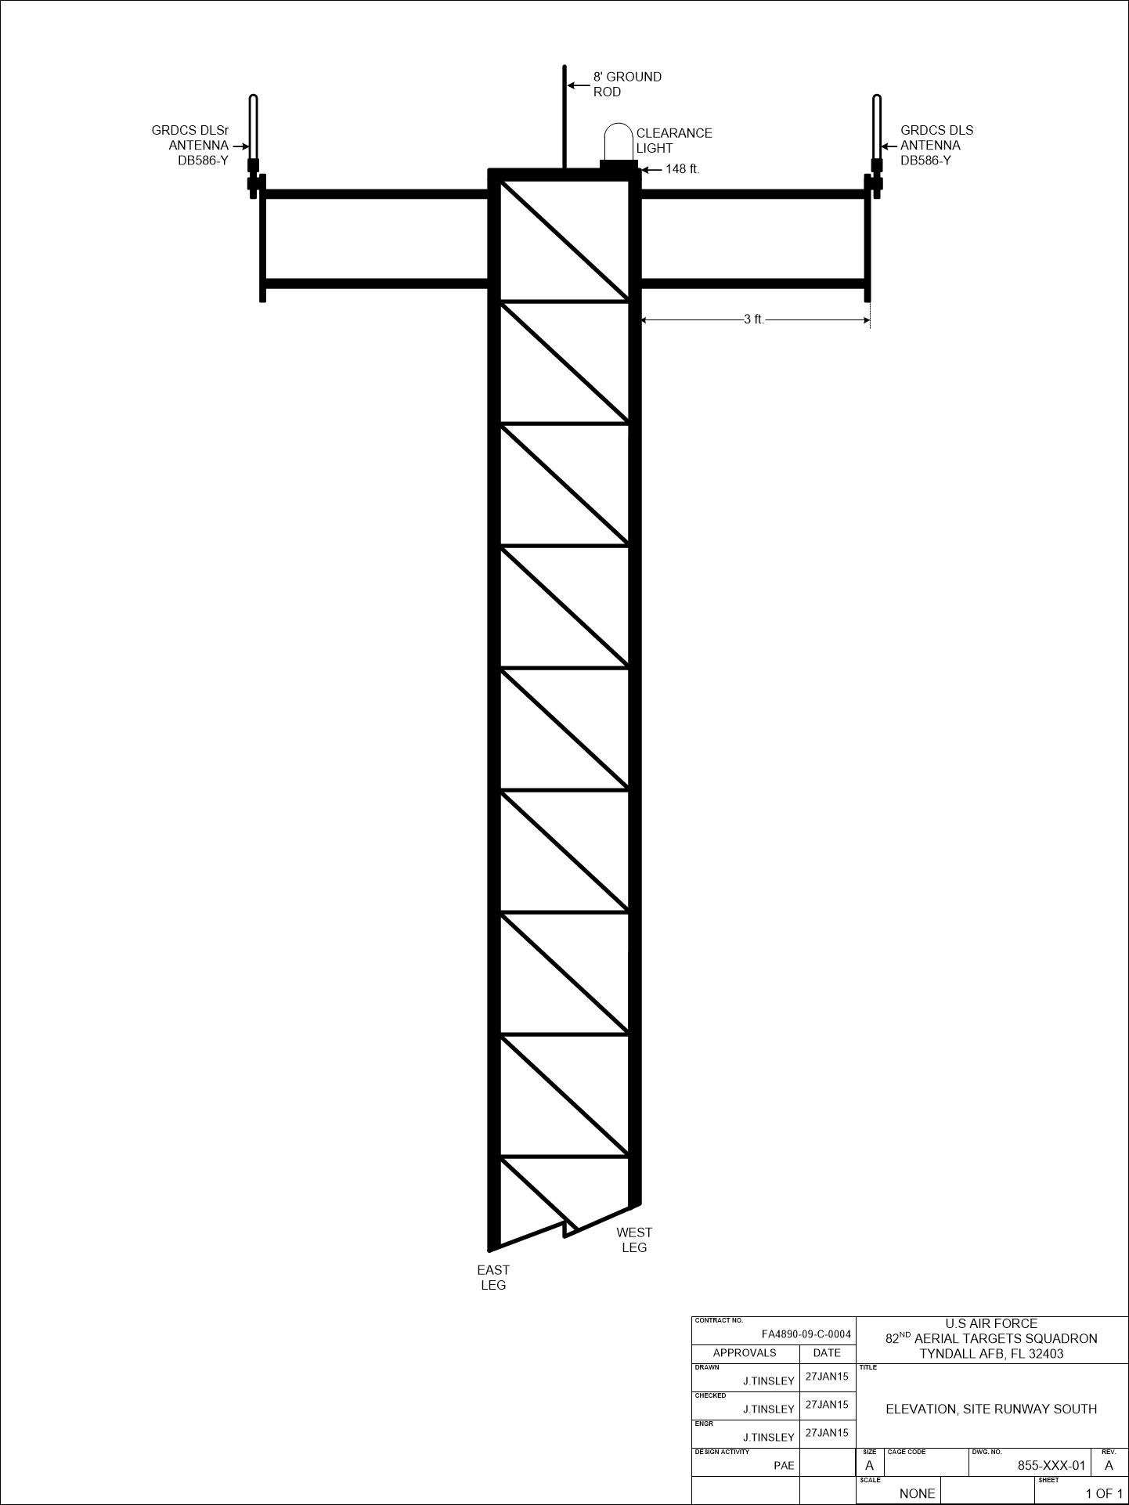

## APPENDIX D

Breaker Panel Schedule (Notional)

